File Security program Analysis

Project Idea:
For my project, I am making a file security program that will allow the user to select files to encrypt so that if someone else is trying to access their data, they will not be able to open the files.
To decrypt the user’s selected file, they can use their phone to connect via Bluetooth, and enter the passcode they set when they first set up the program.
I will make a mobile app using Processing to send the passcode from the phone using a keypad design.
They can either just click to open the file within the program and decrypt it temporarily, they can decrypt it fully, or they can remove it from the program. Only allows decryption if phone is connected. This is useful if you are not near your computer, but you have left it logged on to the program, then since your phone will go out of range, you will be logged out of the program, so your important files can’t be accessed if someone, for example, steals your laptop in a coffee shop.
The encryption would have to be quite secure, but I don’t want it to take forever for someone to decrypt a file for use.
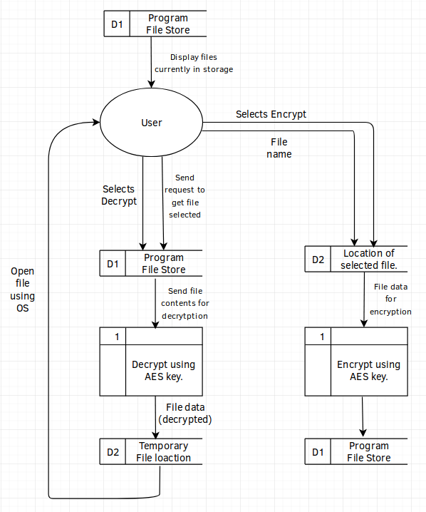
Program Data Flow:

Client:
An example client for my project could be a teacher/school, as they have to keep files about students secure. For example, pupil details, exam results and other important student details.
My program aims to help the teacher/school keep the pupil’s files safe, and prevent the files from being accessed if their device is stolen. It will encrypt files given to the program, and be secured by a pin code that is transferred over Bluetooth to the computer from a mobile device. Once the mobile device is unpaired from the computer, the app will lock again. This will prevent someone from having access to the files if the computer is unlocked and is stolen, as the mobile device will go out of range of the computer, so the computer will lock.
I sent a questionnaire to a member of the IT office at my school to ask what regulations there were about keeping a teacher’s files safe, and what encryption they would suggest for keeping the files secure.

Hi Josh,
What encryption should I use when encrypting the user’s files?
The bare minimum would be 128 bit AES, though 256 bit is recommended.
Are there any standards or laws about what encryption method I should be using for files such as a teacher’s student files (one of the clients for this program)?
Data protection laws. The current UK Law is the Data Protection Act 1998. Though as of 25th May, the law will be General Data Protection Regulations (EU Law regarding all EU Citizens). This is a very complicated law, that is causing headaches for businesses worldwide. I’ve attached some links you might find useful regarding GDPR towards the end of this email.
Hope this helps!
Many thanks
Mr _____
https://www.eugdpr.org/
https://itpeernetwork.intel.com/gdpr-opportunity-rethink-security/
https://ico.org.uk/for-organisations/guide-to-the-general-data-protection-regulation-gdpr/
https://media.datalocker.com/marketing/GDPR_infographic_2017.pdf
https://www.kingston.com/en/usb/resources/eu-gdpr

I will be using this information as guidance for what I have to take into consideration. I will keep in mind the data protection laws when I am storing the user’s files, and make sure I am within the regulations.
The data protection rights consist of (As of 25/05/18):
Breach Notification:
If a data breach has been found and it might “result in a risk for the rights and freedoms of individuals”, then the person that the data belongs to has to be notified within 72 hours.
Right to Access:
The person who’s data it is can at any point ask for confirmation as to whether or not data concerning them is being processed, where it is being processed if it is and for what purpose.
Right to be Forgotten:
The data subject can ask for their data to be erased, and stop the processing of their data. This will be done depending on whether there is public interest in their data (e.g if a politician says something stupid then they can’t ask Google to delete it just because it makes them look bad), and if the data is no longer relevant (e.g your cookies from last week that were used for targeted ads).
Data Portability:
The data subject should be allowed to ask to receive the data, and they should also be able to change which company is controlling their data.
Privacy by Design:
Tells the controllers of the data to only use the data absolutely necessary for the purposes they need it for. For example, an advertisement company might use your cookies to target ads to you, however they can’t then use your location unless they are also using that to target ads. Basically don’t take more than you need.

For my project, as the user is the data controller, then they already have the right to access, the right to be forgotten and data portability. For the breach notification, they will probably know it has happened as someone needs to have physical access to where the data is stored to breach it.
However, with privacy by design, I will not be using any of the user’s data for advertising, or any other agenda. I will make this clear to the user when they first use the program.
Another issue could be that if a file is deleted, the contents of the file might still remain. To fully remove the file I may have to use a one way function that ruins the data before deletion so that it cannot be accessed after it is deleted.

Research:

Bluetooth:
For the file store to be unlocked, I need to send the passcode to the computer via a Bluetooth connection.
For the computer and android device to connect to each other, one device has to be assigned as the server, so it makes sense to me to use the computer as the server, as it will make more sense when using the program.
For the mobile app, I will be using Processing, a java IDE, to program the app. I will be using the android.bluetooth library that is included in the android SDK to transmit the data via Bluetooth.
I will have to use android permissions to enable Bluetooth for use, and for this I will need to use other classes from the SDK.
For the Bluetooth server (on the pc), I will be using Python to receive the pin from the mobile device using PyBluez, check the sent pin, and send a message back saying if the code was valid or not.
If the code is not valid, a message will be displayed on the computer that the code is invalid, and the code on the screen of the phone will be erased.
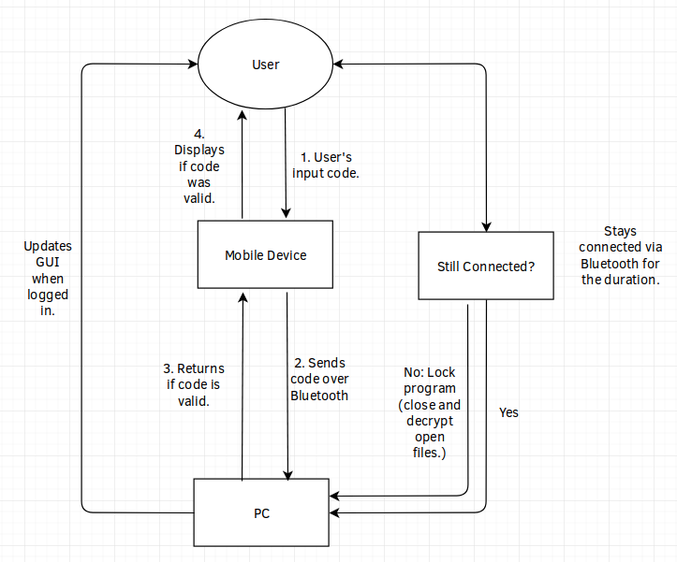
Bluetooth Data Flow:

Storing the files:
For storing the files, I will storing the encrypted files in it’s own directory.
The directory will be managed using a tree structure, where the root folder contains folders for each file, with the name of the folders being the ID of the item added to the program. Each ID folder will contain the encrypted contents of the file.
The encryption method I will use AES 128 bit, as it will slightly compromise security over using 256 bit, however it will be faster to decrypt files for use, giving the user a better experience, however I might add an option to use 256 in the settings if the user needs more security over performance.
For the encryption key, one method could be that the key of the AES encryption is derived from user’s pin code using an algorithm to determine a 128/256 bit key from the user’s password.
This method would be good because it would mean that the key would not be stored on the computer, however I am not sure how they would be able to restore their files if they forgot their key, as a “forgot my password” button would not work, as the files are encrypted using their original pin code.
For the other methods (storing the encryption key), I could either store the key on the computer, and in the OS make it so that the key cannot be accessed by any other groups on the computer, or use DPAPI (Data Protection application programming interface) which is an API built into Windows that allows the password for the user’s Windows account to securely store the data.
In case the user forgets the pin code, the user could either have a “forgot pin code” hyperlink that allows the user to change their code. This would not work with the “derive key from pin code” method I suggested earlier, as the key is derived from the code, so if the code was changed, then it would just break, so that method could not be used if there was a “forgot pin code” button.
AES:
History:
In 1997, the encryption standard at the time, DES, was becoming obsolete due to the advancements in the computer industry. This resulted in the National Institute of Standards and Technology in the United States to call for a new advanced encryption standard (AES).
They held a competition that consisted of 15 different algorithms that had been submitted by different teams. The algorithm that won was an algorithm called Rijndael, an algorithm created by two Belgian cryptographers – Vincent Rijamen and Joan Daemen.
One of the reasons AES has been more successful than DES so far is that AES was thoroughly tested by members of the public during the competition, analysing every aspect of the algorithms to find a way to break them. On the other hand, DES was created in secrecy by IBM in the 70s, and the algorithm was only released a few years later.
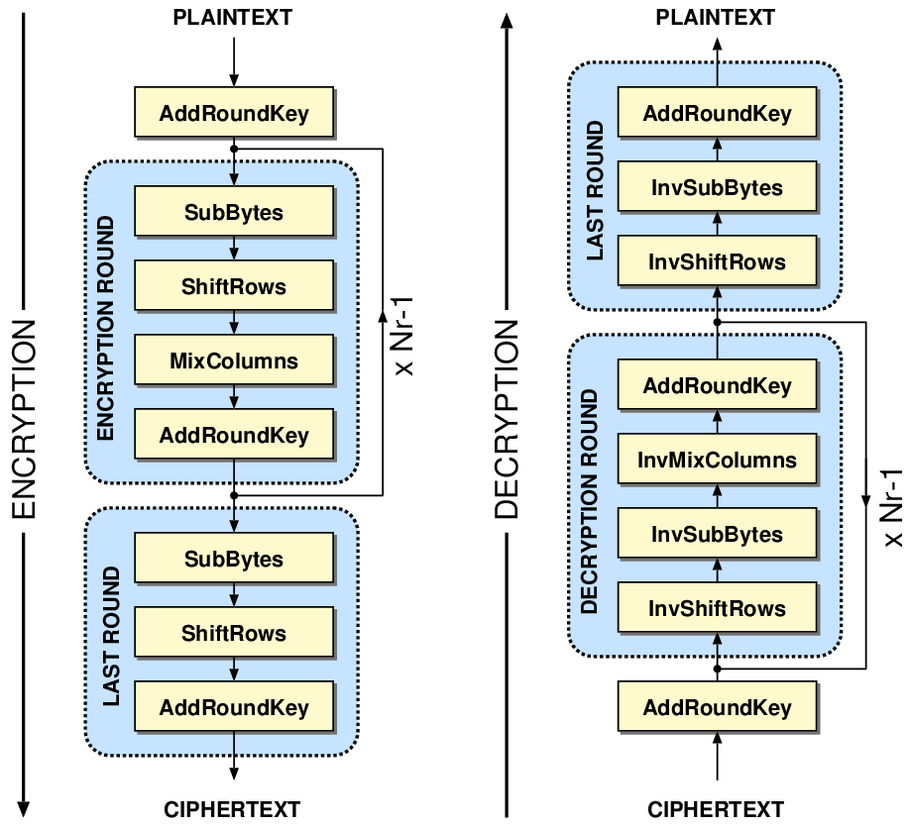
The Algorithm:
AES works by using a block cipher, so it splits the data given into 128 bit, 192 bit or 256 bit chunks depending on what AES you choose (128, 192 or 256). Then you XOR each bit of the 128 bit chunk of data (if using 128 bit AES) with the corresponding byte of the key, like this: (http://www.moserware.com/2009/09/stick-figure-guide-to-advanced.html)
With the message “ATTACK AT DAWN” and key “SOME128BITKEY”.
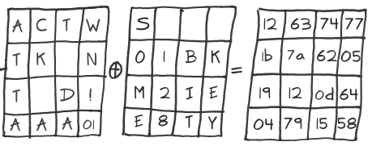

- The Rounds:

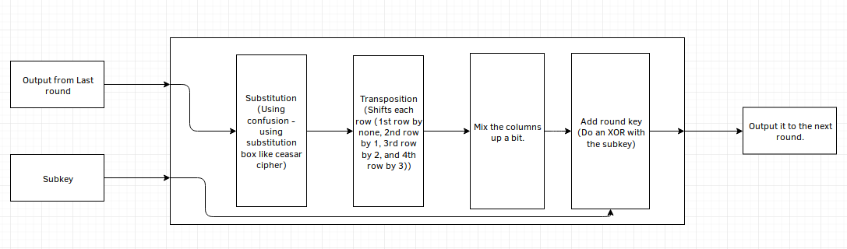

- Overview of the process:

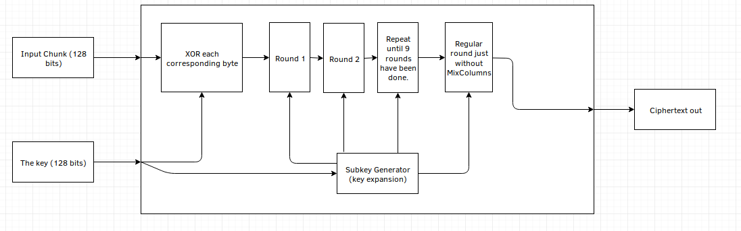

The subkey is generated by key expansion:
1. Take the last column from the key given and move the top byte of the column to the bottom.
2. Use a substitution box (like ceasar cipher) to map each byte to something else.
3. XOR the column with 4 different constants that change each round.
4. XOR this with the first column of the key given.
5. With that new column, XOR that with the next column (3rd in this case) to produce the next column of the key. Repeat this for each column.
AES is a symmetric cipher, so the key given when the file is encrypted is also used to decrypt the file.
For each level of AES, 10 rounds of the cipher is run on 128 bit, 12 rounds on 192 bit and 14 rounds on 256 bit. Each round transforms the input into cipher text.
256 bit takes considerably longer than 128 bit due to these extra rounds.
UI Design:
App:
The app’s GUI design will be very simplistic, as it is just a number pad. I have already started working on the app so this is the UI so far (using the Processing IDE):
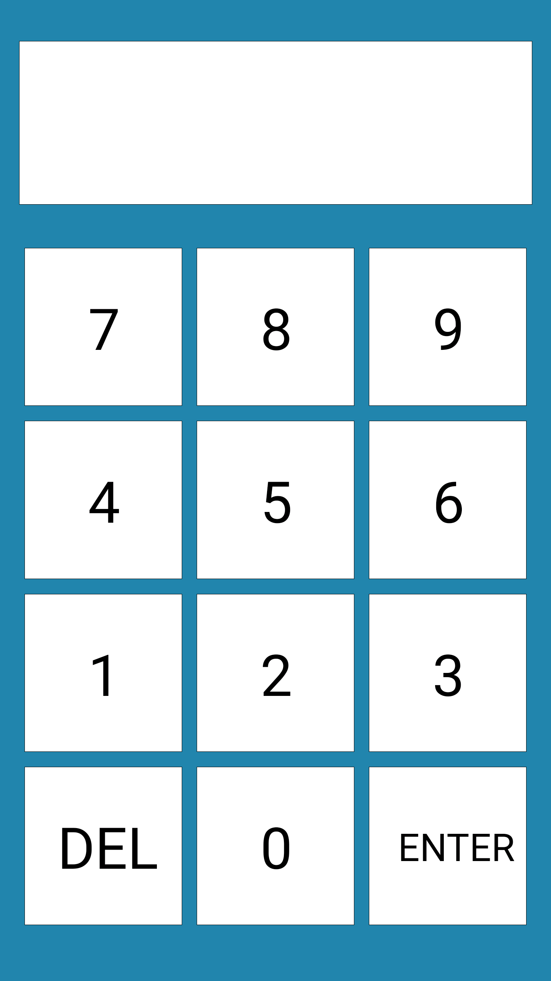
I will probably change it to display 6 separate boxes at the top instead of one, and limit the code to 6 digits.
Other than that, this is pretty much the design for the app. Alerts for if the code is valid or not will fill the screen so the user can’t miss it. The message will be able to be dismissed by touching the screen.
At the moment it doesn’t scale very well on other devices, so I need to fix that.
Here is a class diagram for the app:
(There are only 2 classes; one for the buttons, and one for the display.)
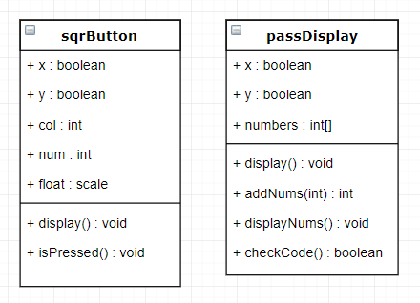

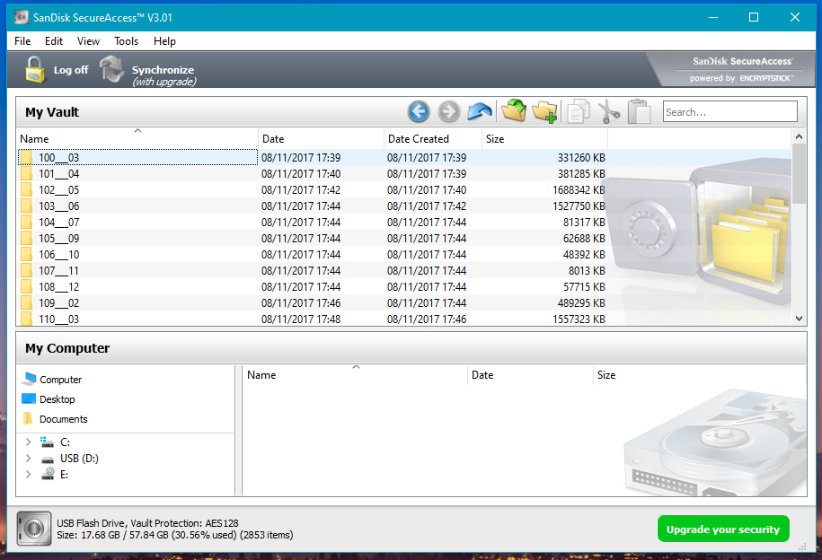
The main app (running on the computer):
For the main app, I will design it similarly to SanDisk Secure Access, as it has an intuitive layout. Here is a screenshot from Secure Access.
As you can see, it is simply laid out, and shows you all the information that you need, without overloading the user with information.
The features I would include in the GUI would be:
1. The list of files displayed neatly, and sortable by the user.
2. The amount of available space left for the user to use.
3. The size of the storage location.
4. The option to log on and off.
5. Folder navigation buttons.
6. The size of each file listed.
7. Estimated time to decrypt (based on decrypting files before (size of file / time taken), or the user can run a test on first use to get estimations right away).
8. Look OK, maybe use kivy in python to make it look decent, as some programs that use kivy look quite nice.
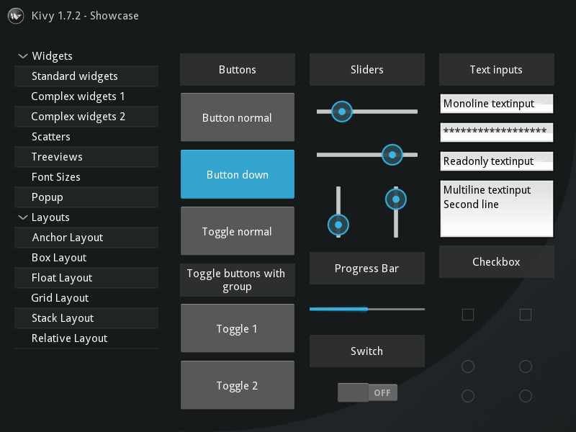
<--- Some of the things you can do with kivy.

9. Keep the stuff going on in the background, in the background.

Objectives:
- GUI should:
- Be easy to use.
- Logically laid out.
- Simple options, have a separate options tab for more advanced options.
- Display the files currently stored, along with the file extension and the size of the file.
- Display the storage space remaining.
- The user should be able to easily encrypt and decrypt files.
- Using a button in the UI.
- Using drag and drop. (?)
- Have an options menu, including the option to:
- Change security level (from 128bit AES to 256bit AES).
- Change the location where the encrypted files are kept.
- Change the pin code.
- Make it easy to select files and change the directory structure (add new folders etc).
- Have a login screen.
- Ask the user to enter the pin from their phone. On the app, they can connect to the PC via Bluetooth, and send the code to the PC. If the code is correct, continue to the main program. If not, erase the input code on the phone and show a message saying “Incorrect pin code.”.
- Allow the user to change their pin when logged in.
- Allow the user to change their pin if they have forgotten it using email or security questions.
- Look decent and not look like it came from the 90s (Maybe use kivy).
- App should:
- Be easy to use.
- Connect via Bluetooth to the PC.
- Allow the user to input a 4/6 digit code (as explained in research).
- Allow the user to send the code from the phone to the PC.
- Tell the user if the code is wrong or correct.
- Be a simple number pad with a display.
- Have a recycling bin, in case of accidental deletion, however delete the files if they have been in there for longer than 2 months, to prevent it building up and taking up storage space.
- Storing the files:
a. Store the encrypted contents in the location specified by the user.
i. Give each file an ID, so that if someone is just looking at where it is stored, it’s not clear what file it is.
b. Keep encryption key in safe location, either by:
i. Not allowing any users to access the file (using OS).
ii. Using DPAPI as explained in Research.
iii. Don’t store it at all and use the passcode as the encryption key
c. Encrypt and decrypt relatively quickly, while still being secure.
d. When the Bluetooth device goes out of range, encrypt everything again and lock the program until the device is reconnected (in case the main device has been stolen).
e. Have an area for the recycling bin.

